The Frogs Who Wished for a King
by Aesop
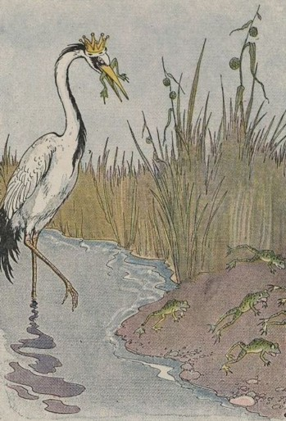
The Frogs were tired of governing themselves. They had so much freedom that it had spoiled them, and they did nothing but sit around croaking in a bored manner and wishing for a government that could entertain them with the pomp and display of royalty, and rule them in a way to make them know they were being ruled. No milk and water government for them, they declared. So they sent a petition to Jupiter asking for a king.
Jupiter saw what simple and foolish creatures they were, but to keep them quiet and make them think they had a king he threw down a huge log, which fell into the water with a great splash. The Frogs hid themselves among the reeds and grasses, thinking the new king to be some fearful giant. But they soon discovered how tame and peaceable King Log was. In a short time the younger Frogs were using him for a diving platform, while the older Frogs made him a meeting place, where they complained loudly to Jupiter about the government.
To teach the Frogs a lesson the ruler of the gods now sent a Crane to be king of Frogland. The Crane proved to be a very different sort of king from old King Log. He gobbled up the poor Frogs right and left and they soon saw what fools they had been. In mournful croaks they begged Jupiter to take away the cruel tyrant before they should all be destroyed.

"How now!" cried Jupiter "Are you not yet content? You have what you asked for and so you have only yourselves to blame for your misfortunes."

The Town Mouse & the Country Mouse by Aesop
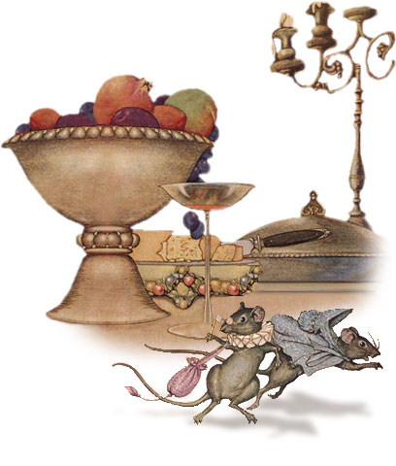
A Town Mouse once visited a relative who lived in the country. For lunch the Country Mouse served wheat stalks, roots, and acorns, with a dash of cold water for drink. The Town Mouse ate very sparingly, nibbling a little of this and a little of that, and by her manner making it very plain that she ate the simple food only to be polite.
After the meal the friends had a long talk, or rather the Town Mouse talked about her life in the city while the Country Mouse listened. They then went to bed in a cozy nest in the hedgerow and slept in quiet and comfort until morning. In her sleep the Country Mouse dreamed she was a Town Mouse with all the luxuries and delights of city life that her friend had described for her. So the next day when the Town Mouse asked the Country Mouse to go home with her to the city, she gladly said yes.
When they reached the mansion in which the Town Mouse lived, they found on the table in the dining room the leavings of a very fine banquet. There were sweetmeats and jellies, pastries, delicious cheeses, indeed, the most tempting foods that a Mouse can imagine. But just as the Country Mouse was about to nibble a dainty bit of pastry, she heard a Cat mew loudly and scratch at the door. In great fear the Mice scurried to a hiding place, where they lay quite still for a long time, hardly daring to breathe. When at last they ventured back to the feast, the door opened suddenly and in came the servants to clear the table, followed by the House Dog.
The Country Mouse stopped in the Town Mouse's den only long enough to pick up her carpet bag and umbrella.
"You may have luxuries and dainties that I have not," she said as she hurried away, "but I prefer my plain food and simple life in the country with the peace and security that go with it."

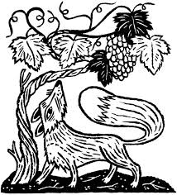
The Fox & the Grapes By Aesop

A Fox one day spied a beautiful bunch of ripe grapes hanging from a vine trained along the branches of a tree. The grapes seemed ready to burst with juice, and the Fox's mouth watered as he gazed longingly at them.
The bunch hung from a high branch, and the Fox had to jump for it. The first time he jumped he missed it by a long way. So he walked off a short distance and took a running leap at it, only to fall short once more. Again and again he tried, but in vain.
Now he sat down and looked at the grapes in disgust.
"What a fool I am," he said. "Here I am wearing myself out to get a bunch of sour grapes that are not worth gaping for."
And off he walked very, very scornfully.

The Boy Who Cried Wolf
An Aesop fable adapted by Louis Untermeyer

A boy employed to guard the sheep
Despised his work. He liked to sleep.
And when a lamb was lost he’d shout
“Wolf! Wolf! The wolves are all about.”
The neighbors searched from noon ‘til nine
But of the beast there was no sign
Yet “Wolf!” cried the boy the next morning when
The villagers came out again.
One Evening around 6 o’ clock,
A real wolf fell upon the flock.
“Wolf!” cried the boy.” A wolf indeed.”
But no one paid him any heed.
Although he screamed to wake the dead,
“He’s fooled us every time.” They said.
And let the hungry wolf enjoy
His feast of mutton, lamb and boy.
The moral is this:
A man who is wise,
Does not defend himself with lies.
Liars are not believed forsooth,
Even when liars tell the truth.

Belling the Cat by Aesop
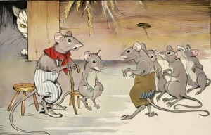
The Mice once called a meeting to decide on a plan to free themselves of their enemy, the Cat. At least they wished to find some way of knowing when she was coming, so they might have time to run away. Indeed, something had to be done, for they lived in such constant fear of her claws that they hardly dared stir from their dens by night or day.
Many plans were discussed, but none of them was thought good enough. At last a very young Mouse got up and said:
"I have a plan that seems very simple, but I know it will be successful. All we have to do is to hang a bell about the Cat's neck. When we hear the bell ringing we will know immediately that our enemy is coming."
All the Mice were much surprised that they had not thought of such a plan before. But in the midst of the rejoicing over their good fortune, an old Mouse arose and said:
"I will say that the plan of the young Mouse is very good. But let me ask one question: Who will bell the Cat?"

