GLORY ROAD:
Character Packet

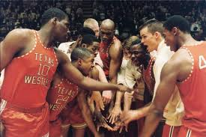

Directions: Under each character’s picture, label a minimum of two defining characteristics.

The following characters have information supplied already for you:
Mary Haskins- Don’s wife, understanding but frustrated by her family’s sacrifice
Dick Meyers- From Kansas, clean-cut
David Palacio- Proud, Hispanic
Togo Railey- not as talented, but enthusiastic
Herman Carr- Black, HS friend of Haskins
Dr. Ray- College President
George McCarty- Athletic Director

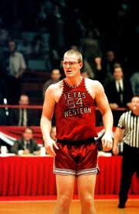
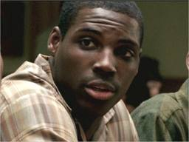
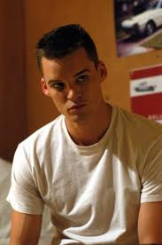

JERRY ARMSTRONG CAGER BAUDOIN

1. 1. 1.
2. 2. 2.
3. 3. 3.
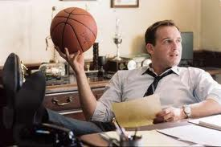
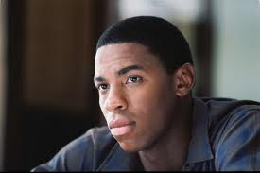
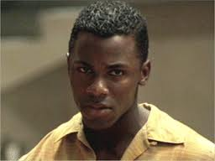

BOBBY JOE HILL FLOURNOY HASKINS
1. 1. 1.
2. 2. 2.
3. 3. 3.
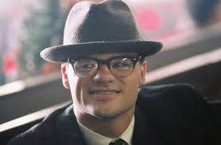
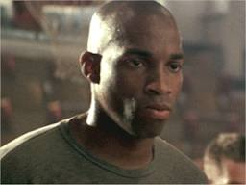
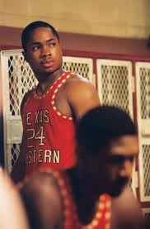
DAVE LATTIN WILLIE WORSLEY
MOE

1. 1. 1.
2. 2. 2.
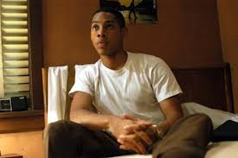
3. 3. 3.
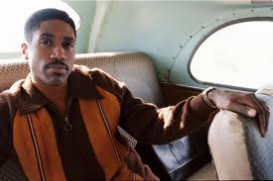
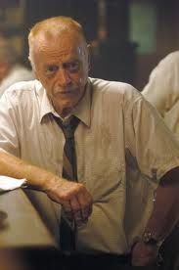
NEVIL SHED

ROSS

ORSTEN ARTIS
1. 1. 1.
2. 2. 2.
3. 3. 3.

