Movie Poster Project
Nancy Drew or Hardy Boys
For this assignment, you will create a movie poster that advertises the book (Nancy Drew or Hardy Boys) that you read. You will be graded on your creativity, attention to detail, as well as the information that you provide. The poster should look like one that you would see in theatres—informative, eye-catching, and interesting to the viewer. It cannot in any way, represent an actual movie poster that has been created through the movie industry.

MATERIALS: Poster board (Minimum size 8½x11), Markers / Colored pencils, Additional Art Supplies
REQUIREMENTS:
1. Your poster must contain original art to represent the main idea of the story. You need at least one main graphic but may choose to include more.
2. Must be in full color. No pencil!
3. Title of story and author’s name must be clearly visible
4. At least one “review” quote from a critic about the story. This should be made-up and is intended to draw the viewer’s interest. No more than 2 sentences.
5. Include a “tagline” for the story. This should act as a “teaser”—make it short and catchy.
6. Be creative and have fun with this!

DO NOT:
• Submit a poster smaller than 8½x11 (standard printer paper) or larger than 22x28 (no trifold boards)
• Copy existing art for the book (the actual cover or your created cover. This is your original work!
• Use a tagline from an existing movie or book
• Leave white/blank space on your poster. It should be completely filled and neat

**Please hand this in when you hand in your project!**

CATEGORY | 3 | 2 | 1 | 0
Graphics - Originality | Several of the graphics used on the poster reflect a exceptional degree of student creativity in their creation and/or display. | One or two of the graphics used on the poster reflect student creativity in their creation and/or display. | The graphics are made by the student, but are based on the designs or ideas of others. | No graphics made by the student are included.
Graphics - Relevance | All graphics are related to the topic and make it easier to understand. All borrowed graphics have a source citation on the back. | All graphics are related to the topic and most make it easier to understand. All borrowed graphics have a source citation on back. | All graphics relate to the topic. Most borrowed graphics have a source citation. | Graphics do not relate to the topic OR several borrowed graphics do not have a source citation.
Required Elements | The poster includes all required elements as well as additional information. | All but 1 of the required elements are included on the poster. | All but 2 of the required elements are included on the poster. | Several required elements were missing.
Attractiveness | The poster is exceptionally attractive in terms of design, layout, and neatness. | The poster is attractive in terms of design, layout and neatness. | The poster is acceptably attractive though it may be a bit messy. | The poster is distractingly messy or very poorly designed. It is not attractive.

Example posters from the real movies:
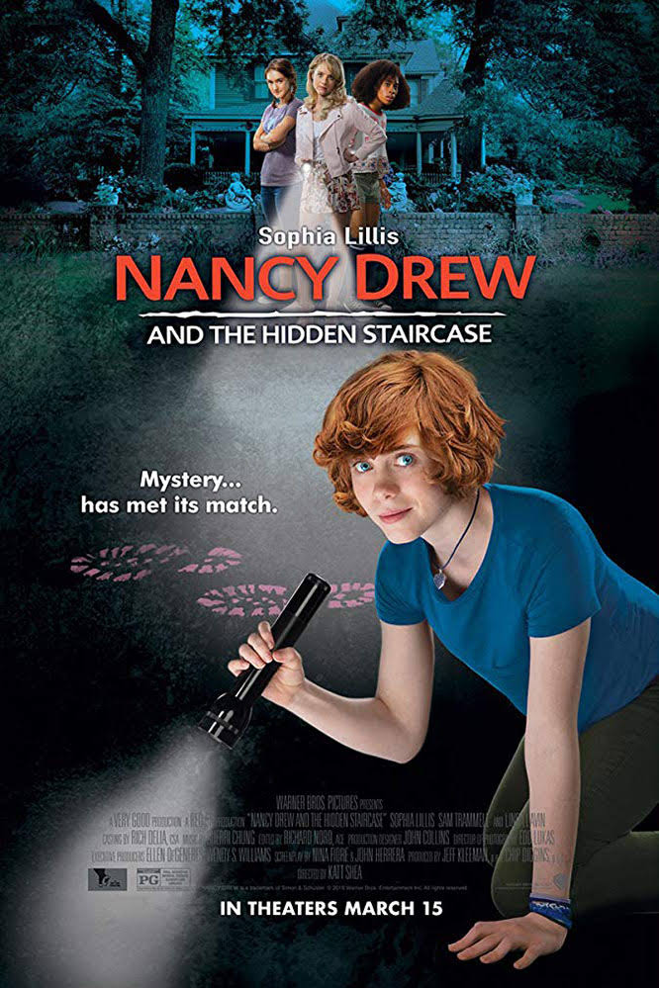 A. B. 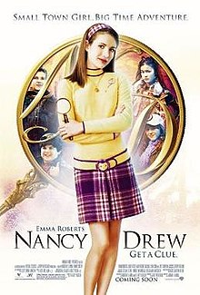
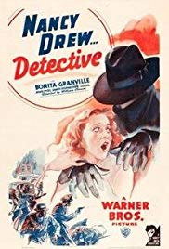C. D. 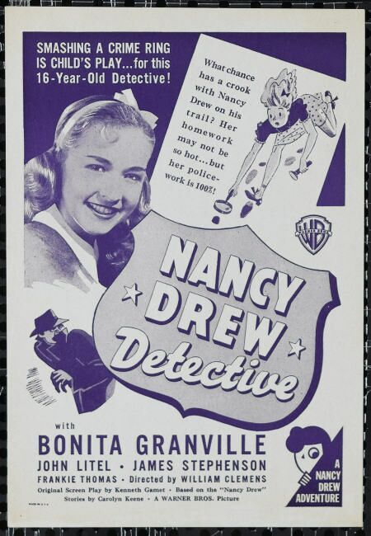
E. 