The Role of Sports Upon the Civil Rights Movement
Rossi Anastopoulo April 16, 2013

When examining the advancement of the civil rights movement through sports, one must first begin with the people who made change happen. Whether it was a conscious stand or unintentional advocacy, athletes and coaches throughout the past century used their participation in sports to change the racial atmosphere in our country. They moved our nation forward into a new way of thinking, and without them we may not enjoy the relative equality we experience today. Such work was not easy, however; these figures overcame countless obstacles and underwent much suffering to emerge as the heroes they are today. Here’s a look at how they were able to accomplish this, what impact athletes had upon societal views, and why they took these stands in the first place.
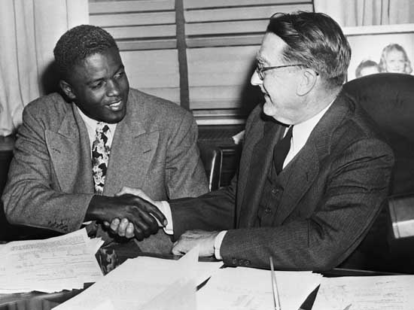
Sports are a unique environment because they capture the attention of nearly the entire country. Not to mention, in the first half of the 20th century, sports provided the primary form of national entertainment because television had yet to become a fixture in the American household. Furthermore, unlike television and movies, the men and women that participate in sports are not characters or personalities; the person seen on the court or the field is the same person off of it as well. Add to this the dedicated allegiance a fan feels for their team (a sentiment amplified to a national scale in the case of a citizen cheering on their country in the Olympics), and all of a sudden the sports world becomes a dynamic atmosphere in which citizens are able to invest their time, thoughts, and emotions. This was fine as long as it resembled society- segregated and based upon the ideas of white supremacy. Indeed, sports serves as a microcosm for society, and once civil rights activists recognized this, they were able to use sports as a platform to advocate social change and equality in the entire country.
The best example of tactic is also the most well known: Branch Rickey’s “noble experiment” and the integration of the MLB by Jackie Robinson in 1947. Prior to Robinson’s MLB debut, baseball, which was America’s pastime, was divided between the dominant all-white major leagues and the lesser negro leagues. In other words, it literally resembled American society at the time. Rickey recognized the power of sports and understood that integration in baseball could be the first step toward integration in society. It was extremely difficult to accomplish, and Robinson underwent tremendous suffering and discrimination because of his ground breaking role. But, once Jackie began playing, the stadiums were packed. Whites cheered for him. The same whites who wouldn’t let a negro drink from the same water fountain were now paying money to see a black man perform on the field and represent their team.
This was an absolutely monumental breakthrough, one that could never be underestimated. Almost twenty years before the Civil Rights Act of 1964, Branch Rickey and Jackie Robinson were sowing the seeds of equality in the hearts of Americans, all under the guise of a hot bat and a few stolen bases. Without Jackie Robinson, nationwide integration doesn’t happen for at least another decade, and white’s attitudes toward blacks remains ignorant and prejudiced. But because of him, America takes one more step toward racial equality, even if it’s only on the baseball field.

Because of his role on a team in America’s most popular sport, Jackie was able to capture the hearts of Americans as a breakout athlete and racial symbol. Meanwhile, other athletes had a tremendous impact on the international stage, whether it was the Olympics or boxing championships. Take, for instance, Jesse Owens. While in Berlin, he served as a representation of American ideals of freedom, democracy, and equality competing against the Nazi ideals of racial supremacy. Because of this stand, American citizens rallied behind him, supporting their athlete from across the ocean. He wasn’t a black man; he was an American. In the end, American patriotism triumphed over discrimination, if only for a short while. Yet upon returning to the United States, Owens was once again treated in a discriminatory manner and bound by the constraints of societal segregation, thus exemplifying the hypocrisy of American attitudes and ideals at the time.
Similarly, Joe Louis was able to become an American hero on the international boxing stage, perhaps never more so than when he defeated Germany’s Max Schmeling in 1938. This boxing matchup captured the same ideals that had been present two years earlier- that of American freedom rising above the beliefs of the Nazi regime. In both cases, American citizens were able to overcome their discriminatory ideologies and view these athletes as men who represented them and their country, as opposed to black men who should be placed below members of white society. But although they were each responsible for seismic, if fleeting, changes in American racial perceptions, I don’t believe either Owens or Louis sought to advocate racial equality through their participation in sports; rather, they each had a passion and a talent, as well as a desire to serve their country, and what emerged were two acts of American heroism that allowed citizens to step outside of their narrow mindsets of racist beliefs and look upon these two African Americans in a whole new light.
Meanwhile fellow athletes such as Althea Gibson and Fritz Pollard also had tremendous impacts in their respective sports through integration and their individual accomplishments. The more they accomplished, the more mainstream and famous an African American face became in the media, and slowly the public began to warm to these black athletes. It was a step in the right direction, although progress was slow. And as more and more African American athletes began to play professional sports, they were able to not only assimilate racial equality into the mindsets of citizens, but also challenge the fundamental ideas upon which racism was based, which is perhaps the most important influence these notable athletes had upon the civil rights movement. This is because their exceptional performance on the field and the court (examples include Jackie Robinson’s Rookie of the Year Award, Althea Gibson’s Wimbledon Championship, Jack Johnson’s heavyweight title, Wilma Rudolph’s gold medals, and more) proved that blacks were equal to whites, thus challenging the ideals of racial supremacy upon which discrimination was based. This idea- that if blacks were equal on the field, they were equal off it as well- began to infiltrate its way into society, thus beginning the subtle yet definitive shift in the American conscious and allowing civil rights activists and athletes to promote social justice in our country.
Not only did these figures begin to affect the white mindset in our country, but they also had an impact upon their fellow African Americans. Because they were willing to expose themselves to the harsh criticism and segregation of the sports world, many of these athletes became heroic figures that served as role models for blacks across the United States. In a country where few African Americans were able to achieve high profile public positions, sports provided a chance for blacks to emerge as public figures, thus inspiring the rest of the African American community to take a stand for their beliefs as well.

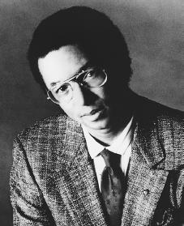
Later in the century, after sports had been integrated and become relatively equal, African American athletes were able to use their place in sports as a platform to speak out on racial and social inequality. This is perhaps best characterized by Muhammad Ali’s outspoken and often controversial public role, as he consistently made brash statements about social justice that gave black athletes, as well as the black community, more of a public voice. This was also exemplified by Arthur Ashe, who said, “I don’t want to be remembered for my tennis accomplishments.” Despite a stellar tennis career that earned him a place in the Tennis Hall of Fame, Ashe’s most lasting impact has been the tireless fight he waged against discrimination and inequality throughout his life. More than any other athlete, Arthur Ashe understood the power his status as a high profile athlete gave him, and as a result, he was able to advocate the social change he believed in. In the end, Arthur Ashe was able to not only revolutionize the game of tennis, which up to that point had never seen an African American male star, but the world as well.
Ultimately, black athletes were able to serve as symbols for their fellow African Americans by representing racial equality and changing the role of the African American community in the United States. It began with initial integration, particularly in professional sports, as the greatest barriers to equality fell with the trail blazing efforts of athletes such as Jackie Robinson and Althea Gibson. These athletes’ athletic performances then went on to prove to society that blacks were equal to their white counterparts, thus challenging and eventually overthrowing ideas of racial supremacy. They also familiarized the white public with the concept of aligning themselves alongside other African Americans as white fans began to unite behind the black stars of their favorite teams. Finally, athletes began to challenge societal inequalities by speaking out against discrimination and making public calls for social justice, thus changing the way African Americans were viewed both in sports and in society. Ultimately, these individual athletic figures were able to unite across decades to change the face of race relations in the United States and bring about a new atmosphere of innovation and racial equality.

