Imagery with pictures

Directions: Choose one of the pictures in each set below. Use imagery (try for as many of the 5 senses as possible) to describe the photo. I should be able to tell which picture you are describing.

Set 1:

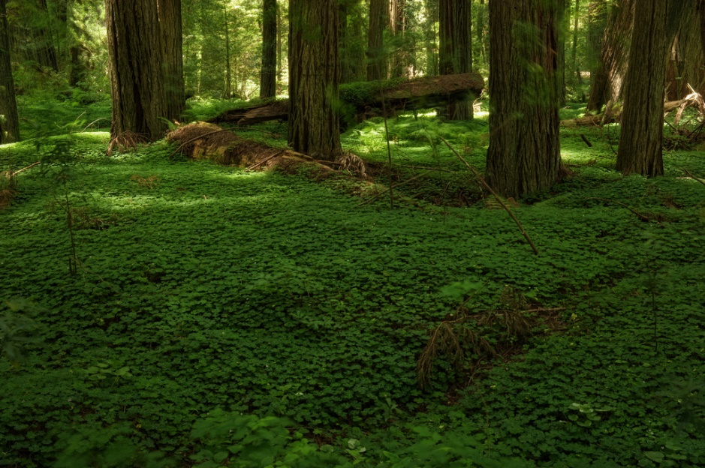

B

A

Set 2:

 

A

B

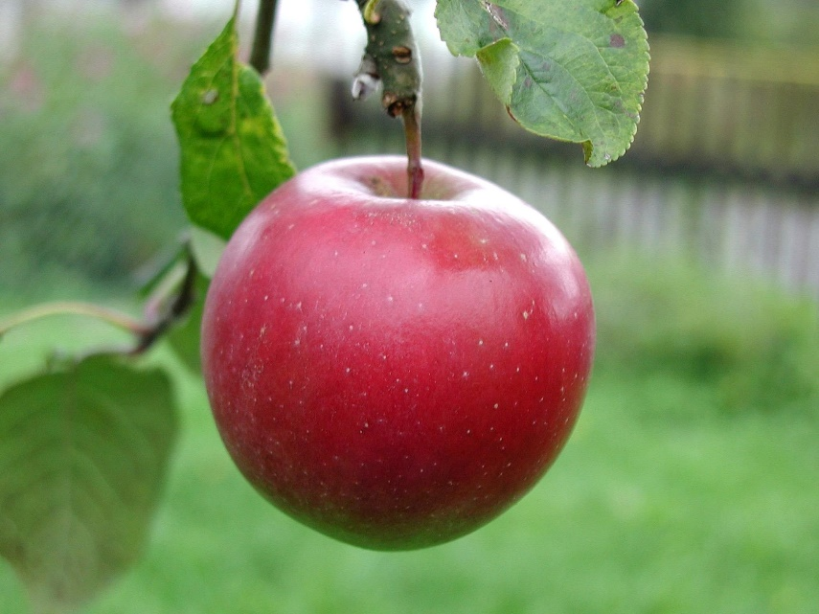Set 3: Ignore hand in picture 2- DO NOT DESCRIBE!

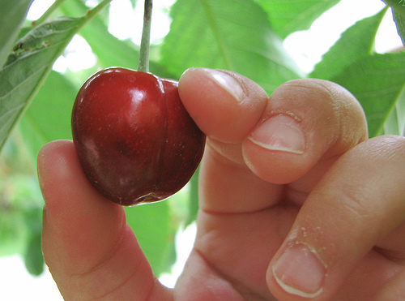

B

A

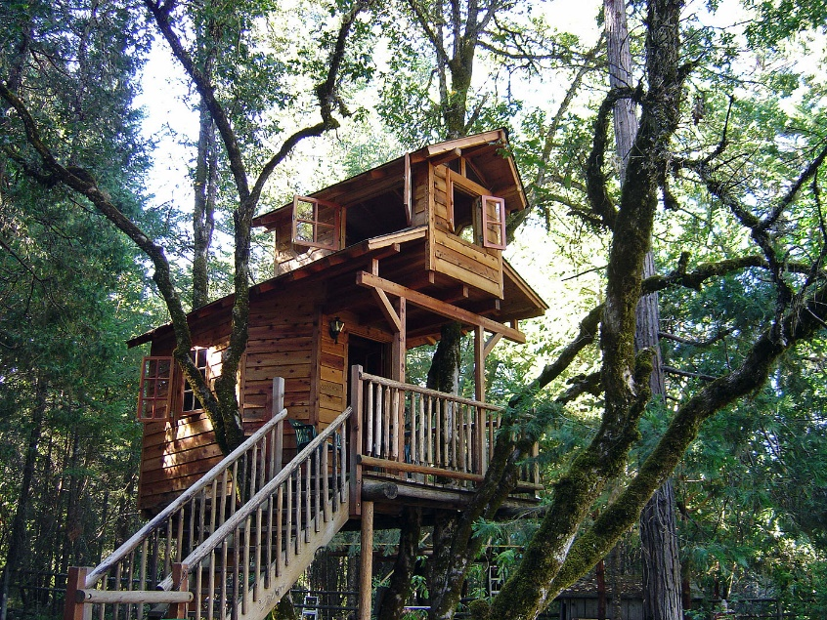SET 4:

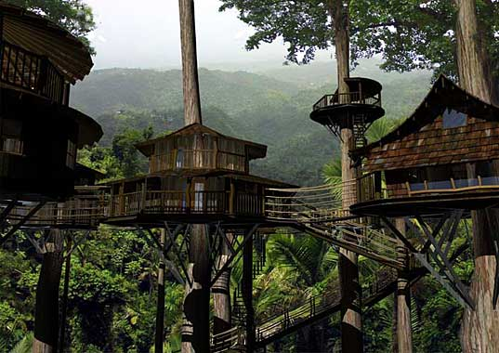

B

A