Nonfiction text feature assignment
Directions: On the computer find examples of each of the text features in your literary terms note book. Under each flap put an example.

Hand written examples:
Draw or write an example of the text feature.
Example:

Printed examples:
Find an example on the computer and copy and paste it into a word document. Resize it/crop it to be small enough to fit under the flap. (you should be able to fix at least 10 examples on a single page before printing.)
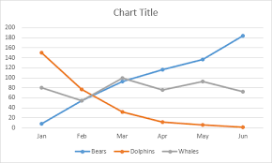
Example:

