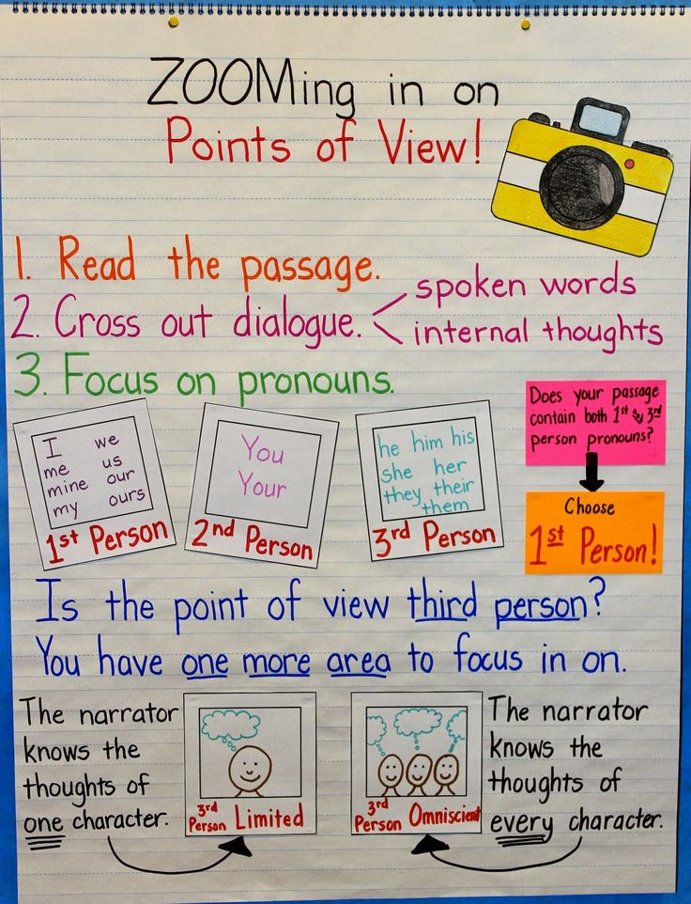

Perspective (sometimes called point of view)- What a character sees through their eyes.

