Coordinating Conjunction definition: A conjunction is _____________
_______________ words, __________________, clauses, or sentences of equal rank to join them.
Examples: F ______________ What shape and color
A ______________ are conjunctions?
N ______________ __________________________
B ______________
O ______________
Y ______________
S ______________
Subordinate Conjunction definition: A conjunction that introduces a
_______________________________clause (some are often called
__________________________words)
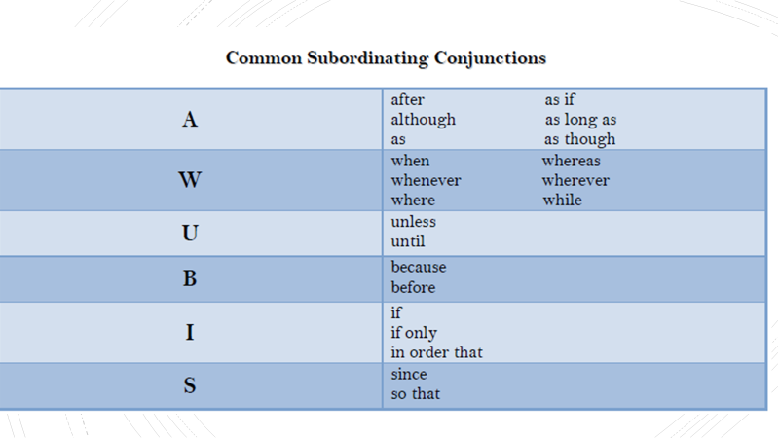

Compound Sentence definition: A sentence including ______________
__________________________ independent clauses combined with a
conjunction or _________________________.
Put the correct shapes over the noun and verb in the two examples!
Example: Sue learned French in school, but her friend learned it online.
Example: Cake is my favorite dessert; pancakes are my favorite breakfast.

Compound subject definition: Two _______________________ simple
subjects joined by a conjunction are ____________ the same predicate.

Put the correct shapes over the noun and verb in the two examples!
Example: Amy and Jenny like cake.

Compound predicate definition: One simple subject performs _______
or more simple predicates that are _______________by a conjunction.

Put the correct shapes over the noun and verb in the two examples!
Example: Belinda shops and eats with her grandma.

