Six-word Memoir
Six-word memoirs originated in SMITH Magazine (http://www.smithmag.net)
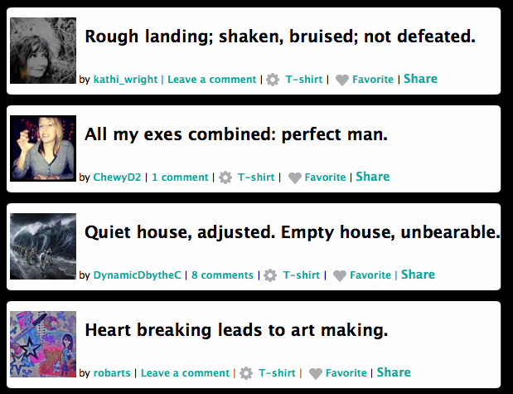

These memoirs caught on quickly and have now appeared across the globe. Here is a great example on YouTube (http://www.youtube.com/watch?v=jEkAHATRuRU).

If you would like more information or are interested in Six-word memoirs, here is an NPR radio spot about them: (http://www.npr.org/player/v2/mediaPlayer.html?action=1&t=1&islist=false&id=123289019&m=123331558)
Both of these memoirs were about the same event, but only the second one makes it clear to the reader.
Bad: Amazing; Painful, Rough; Funny and Dumb.
Good: Backflip; oops. Excruciating; mom laughing hysterically.

Your Six-word Memoir must be a purposeful, strong statement that can tell a story in only six words. It needs to include a photo or illustration that adds to the mood or adds impact to your memoir.
Six-word memoir checklist:
______ Is only 6 words

______ Is a purposeful/strong statement

______ Include a photo or illustration that adds impact or adds to the mood of the memoir

______ Is free of grammar and spelling errors

______ Has my name on it

