The Eagle
He claps the crag with crooked hands;
Close to the sun in lonely lands,
Ring’d with the azure world, he stands.

The wrinkled sea beneath his crawls;
He watches from his mountain walls,
And like a thunderbolt he falls.
-Alfred, Lord Tennyson

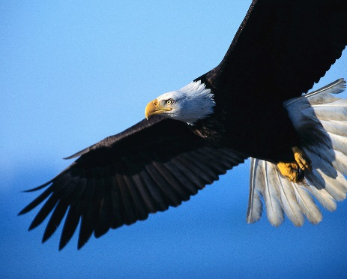
This Photo by Unknown Author is licensed under CC BY-NC-SA

